Data Pool Management
Requirement Document

Module: Enterprise Self-Service Portal
Version: 1.0
Date: 13 April 2026
Status: Draft

Contents
Step 1 — Manage Services: Data Pool Section
Step 2 — Buy Data Pool Plan: Choose Master Number
Step 3 — Select Data Plan
Step 4 — Plan Confirmation & Security Deposit Prompt
Step 5 — Payment Gateway
Step 6 — Payment: PIN Entry, Success & Failure
Step 7 — Payment Success Confirmation
Step 8 — Security Deposit Service Request (Alternate Path)
Step 9 — Add / Remove Dependents (Individual & Bulk)
Step 10 — Data Pool Deactivation
Step 11 — Service Request Detail Page

Step 1 — Manage Services: Data Pool Section
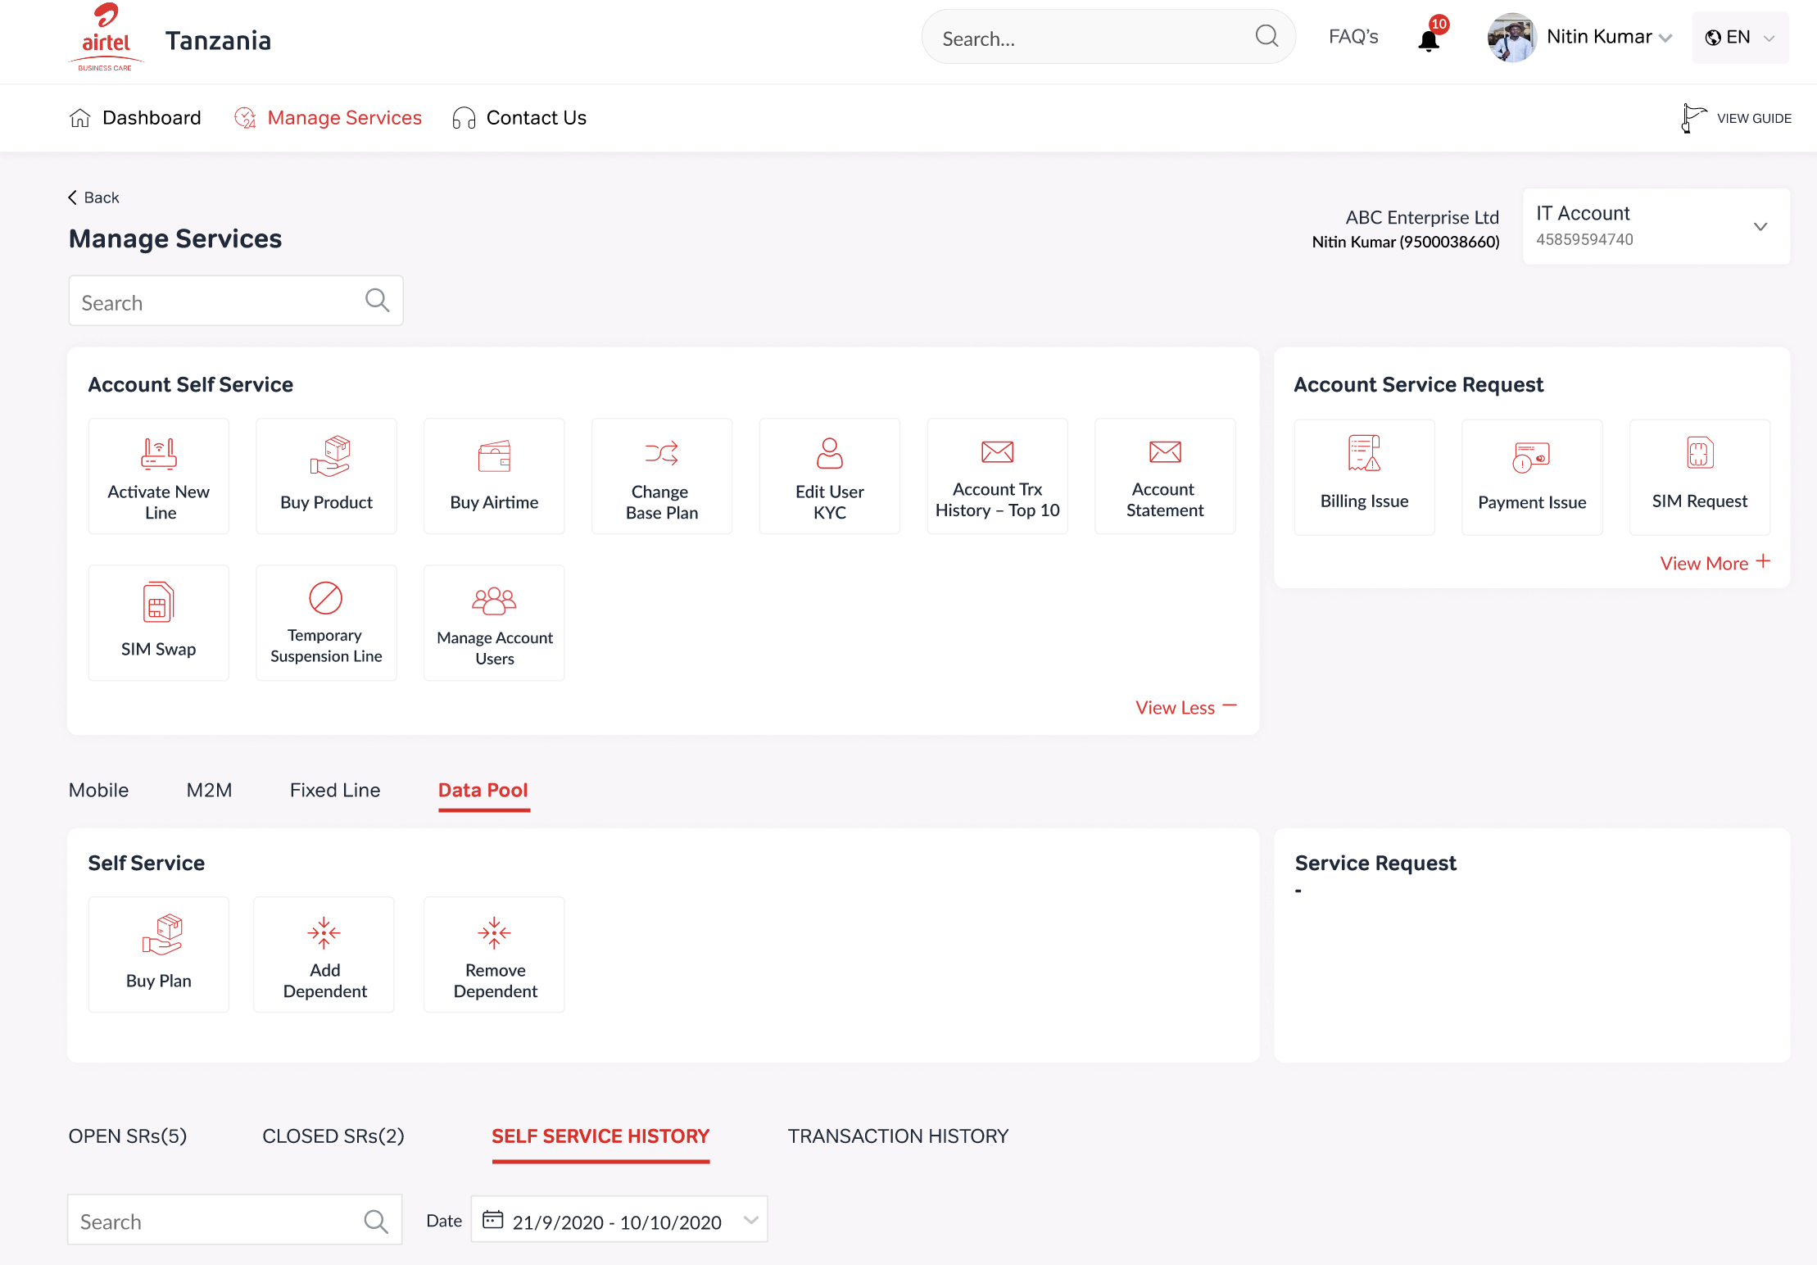
Manage Services page with Data Pool tab selected

Description
The user logs into the Enterprise Portal and navigates to Manage Services from the top navigation. The page shows the enterprise account context (company name, user name, IT account number) and two panels: Account Self Service (with action tiles like Activate New Line, Buy Product, etc.) and Account Service Request.
Below the account-level panels, a tab bar provides access to: Mobile, M2M, Fixed Line, and Data Pool. The user clicks the Data Pool tab.
Under the Data Pool tab, two sections appear:
- Self Service — action tiles: Buy Plan, Add Dependent, Remove Dependent
- Service Request — for raising Data Pool specific SRs
Below these, four history tabs are shown: OPEN SRs (count), CLOSED SRs (count), SELF SERVICE HISTORY, and TRANSACTION HISTORY, with a search bar and date-range filter.

Fields
Enterprise Name: Displayed in header. Example: "ABC Enterprise Ltd"
User Name & MSISDN: Logged-in user. Example: "Nitin Kumar (9500038660)"
IT Account Number: Unique account ID. Example: "4585959474 9"
Search (History): Text input to filter history records
Date Range Filter: Date picker. Example: "21/9/2020 - 10/10/2020"

Validations
- User must be authenticated and linked to an enterprise IT account to access this page.
- Data Pool tab should only appear if the enterprise account has Data Pool feature enabled.
- SR counts (Open/Closed) must reflect real-time data.
________________________________________________________________________________

Step 2 — Buy Data Pool Plan: Choose Master Number
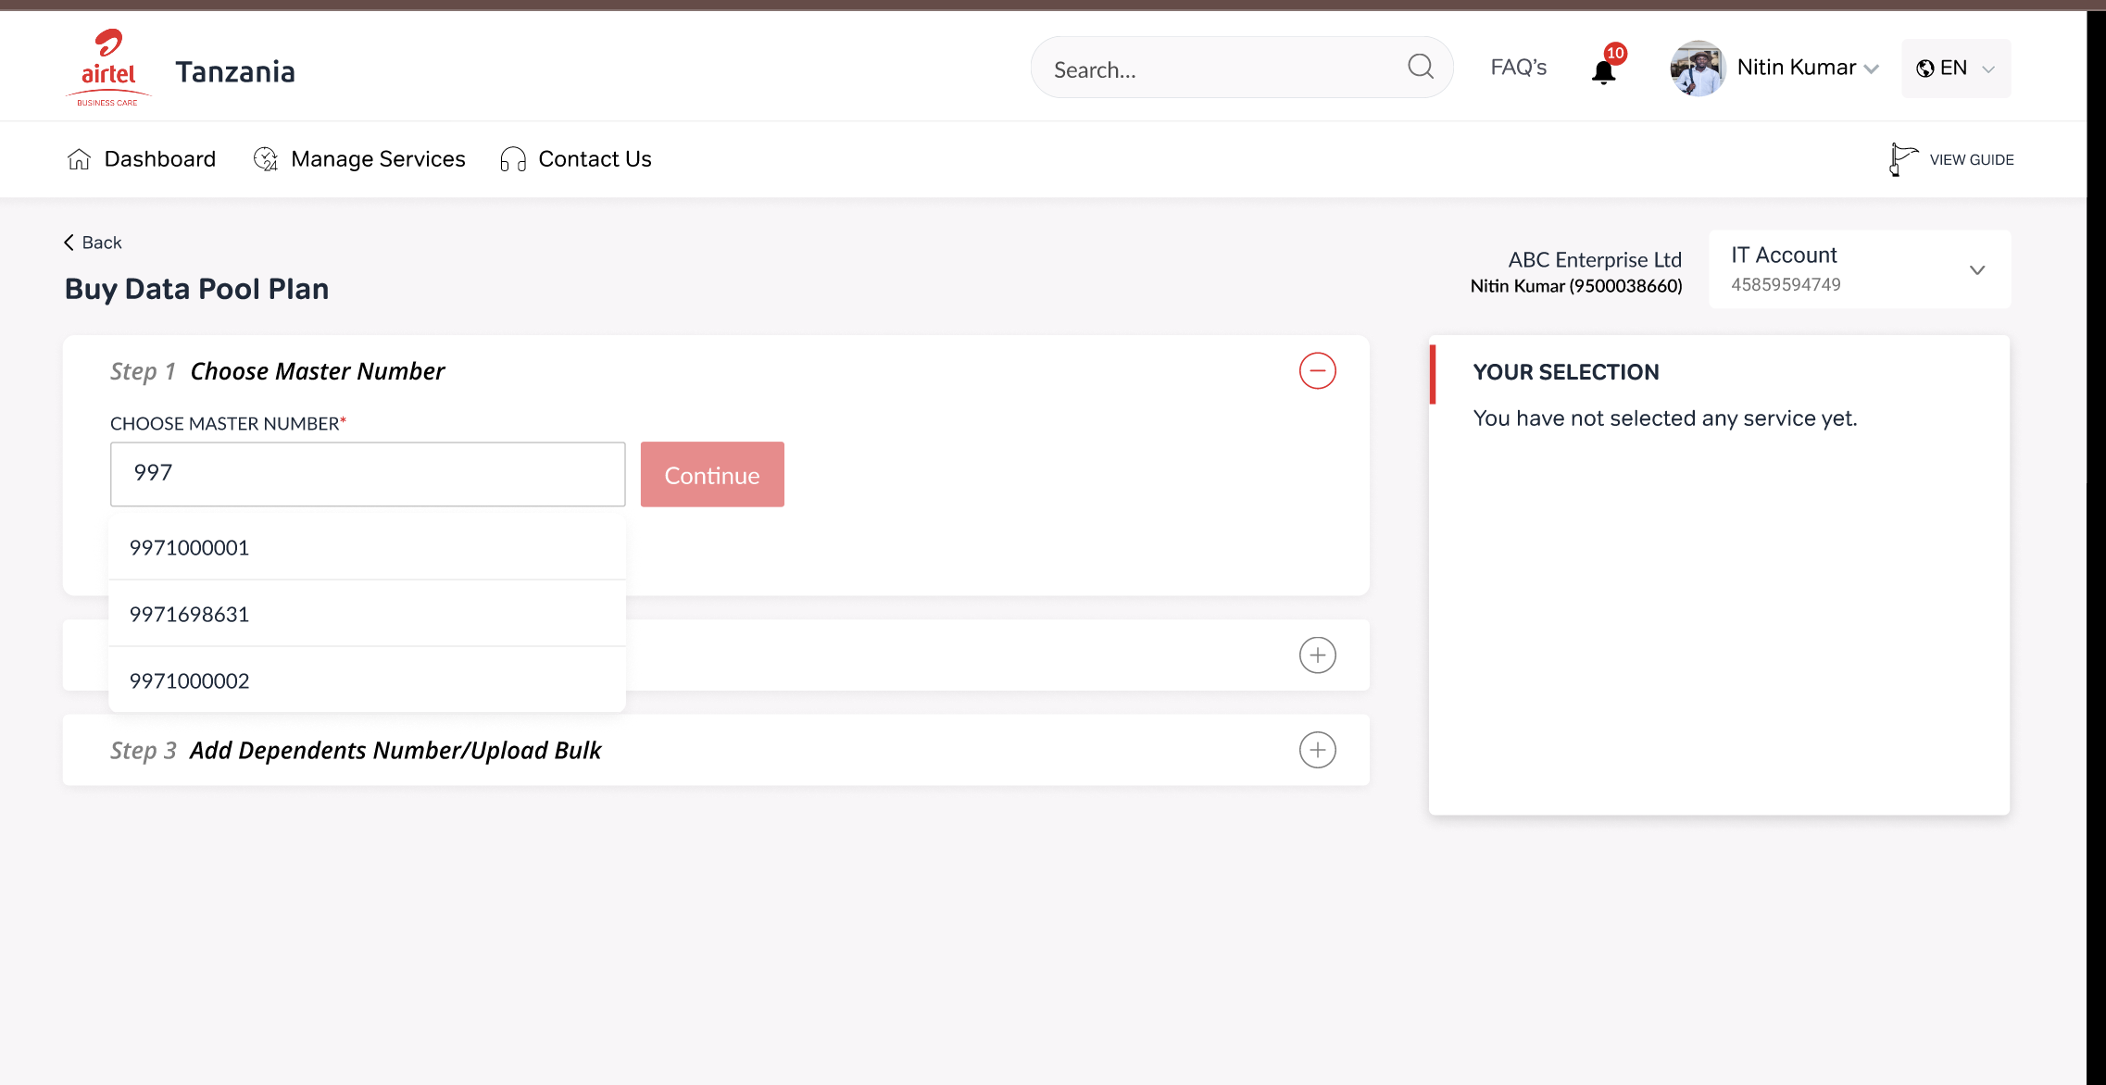
Step 1 of Buy Data Pool Plan — Master Number selection with type-ahead search

Description
User clicks "Buy Plan" from the Data Pool self-service section. The system opens the "Buy Data Pool Plan" page. The first step asks the user to choose a Master Number.
As the user types in the search field, matching master numbers appear in a dropdown (type-ahead). After selecting a number and clicking "Continue", the "YOUR SELECTION" panel on the right updates to show the selected master mobile number.

Fields
Choose Master Number: Search/input field with type-ahead dropdown. [Mandatory]
YOUR SELECTION Panel: Right-side summary. Initially shows "You have not selected any service yet.", then updates with selected master number.
Continue Button: Proceeds to Step 2 (plan selection)

Validations
- Master Number is mandatory. Continue button stays disabled until a valid number is selected.
- Only master numbers belonging to the logged-in enterprise account should appear in the dropdown.
- If a master number already has an active data pool, the system should indicate this or restrict re-purchase.
________________________________________________________________________________

Step 3 — Select Data Plan
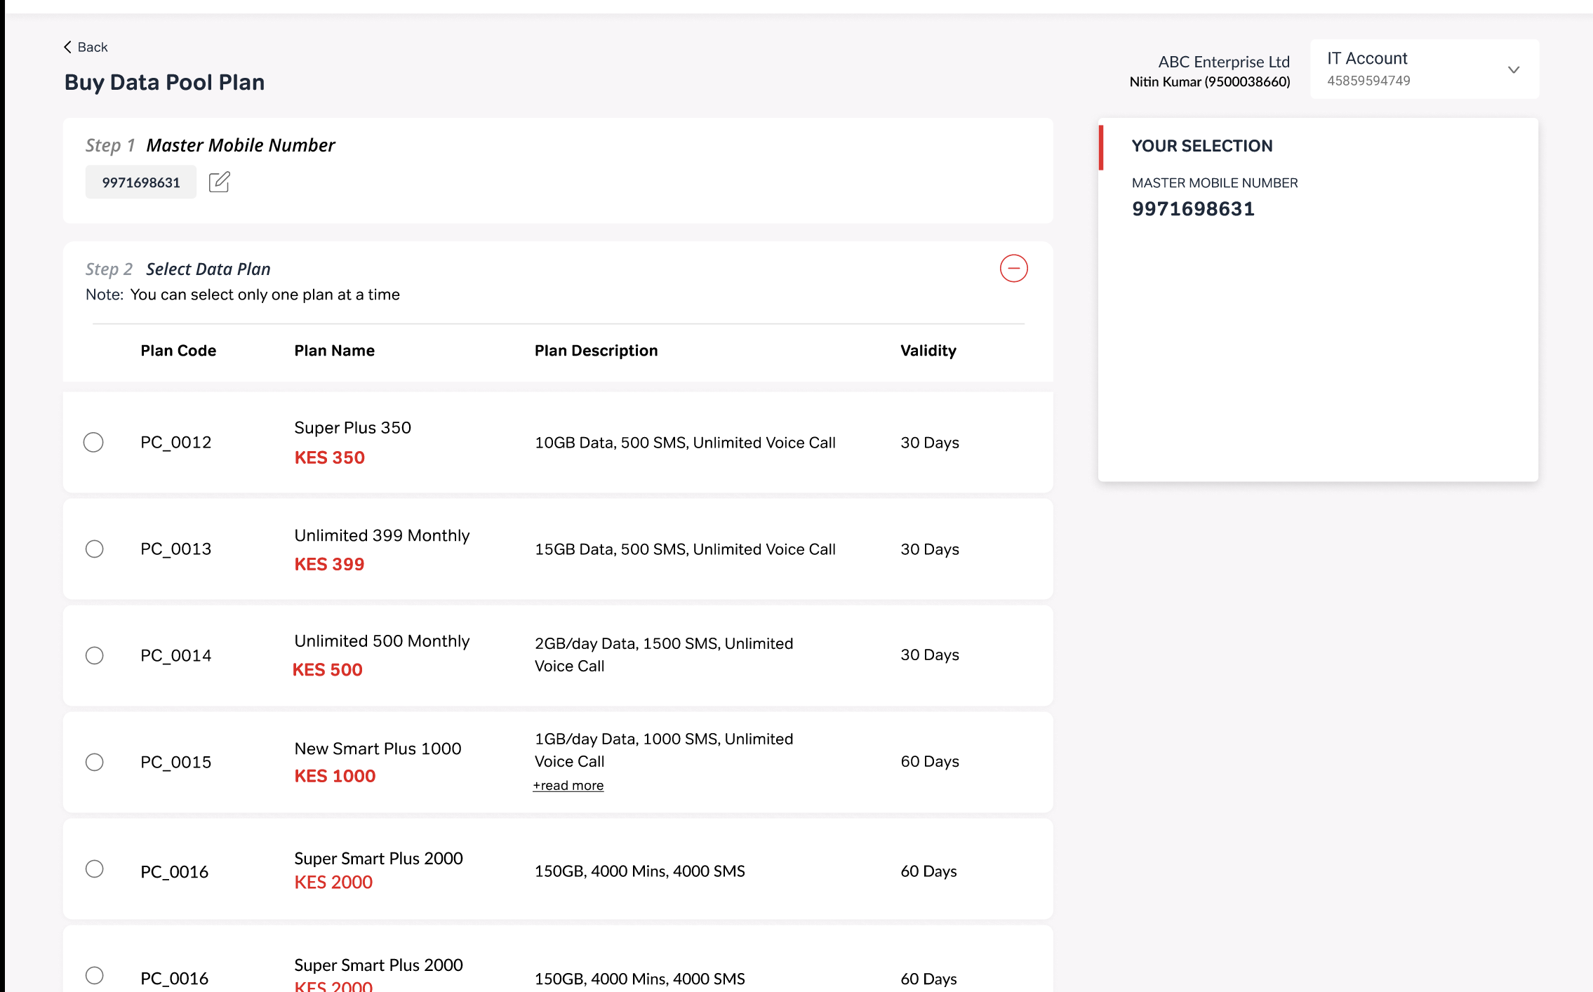
Available plans displayed with plan code, name, price, description, and validity
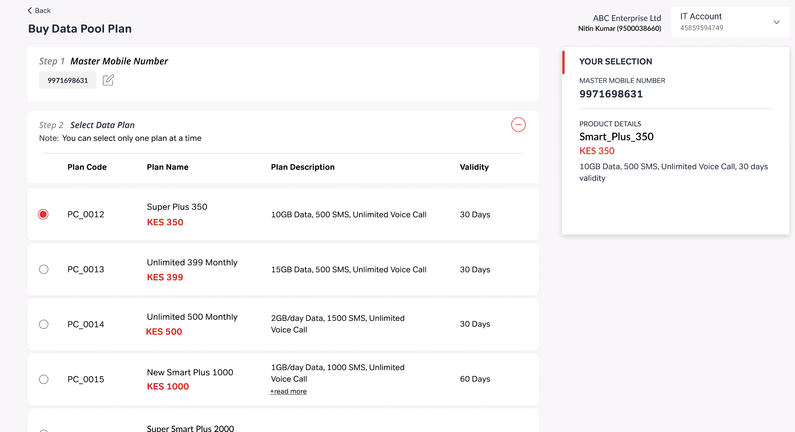
Plan selected (Super Plus 350) — YOUR SELECTION panel updated with product details

Description
After selecting the master number, Step 2 loads a list of available data plans. Each plan shows its Plan Code, Plan Name with price, Plan Description (data, SMS, voice details), and Validity period. The user can select only one plan at a time via radio buttons.
On selecting a plan, the YOUR SELECTION panel updates to show the Master Mobile Number and Product Details (plan name, price, description, validity).
Pagination is available if plans exceed the page size (e.g., "Showing 1 to 10 of 30 rows" with Prev/Next controls).

Fields
Plan Code: Unique identifier. Example: "PC_0012"
Plan Name: Display name with price. Example: "Super Plus 350 — KES 350"
Plan Description: Data volume, SMS count, voice details. Example: "10GB Data, 500 SMS, Unlimited Voice Call"
Validity: Plan duration. Example: "30 Days", "60 Days"
Radio Button (per row): Single-select. Only one plan active at a time. [Mandatory]
YOUR SELECTION Panel: Updates with: Master Mobile Number, Plan Name, Price, Description, Validity
Pagination Controls: Rows per page selector, Prev/Next, page numbers

Validations
- Only one plan can be selected at a time.
- Continue button is enabled only after a plan is selected.
- Plans with long descriptions should show a "read more" expandable link.
- If no plans are available, show an appropriate message.
________________________________________________________________________________

Step 4 — Plan Confirmation & Security Deposit Prompt
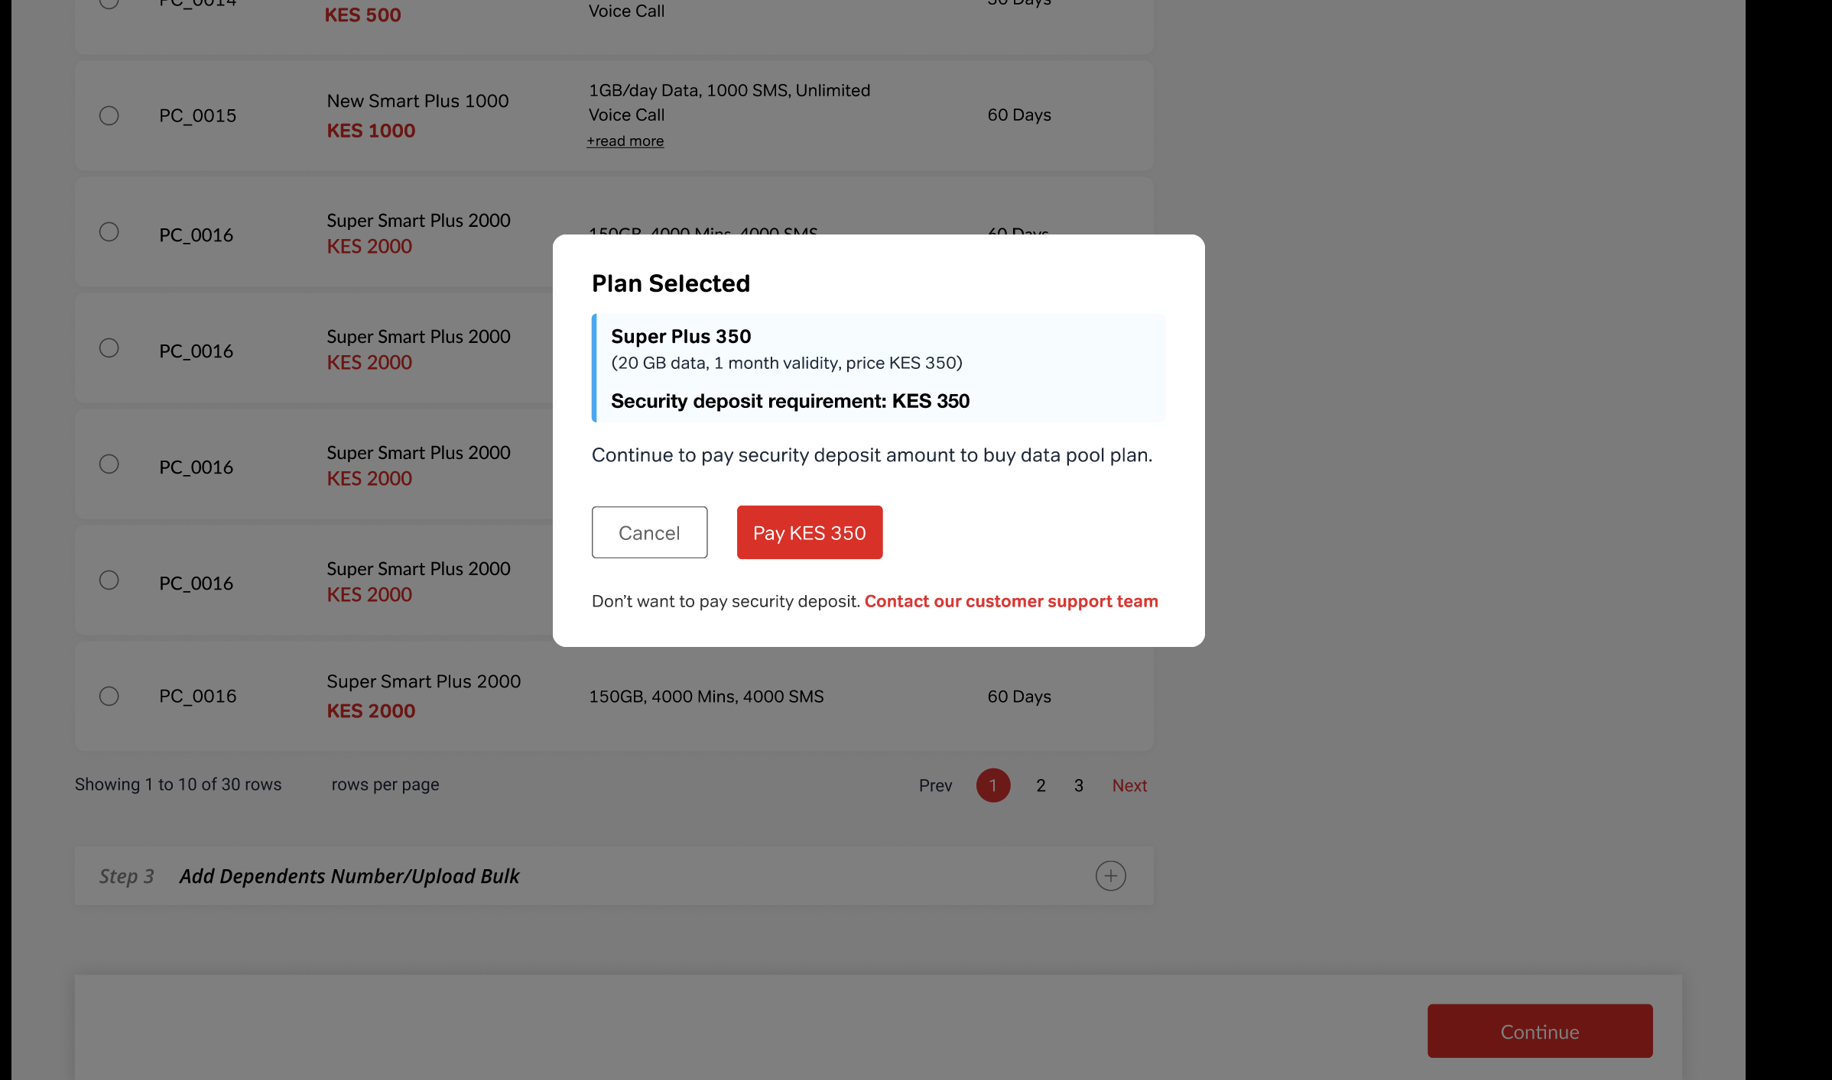
Plan Selected modal — shows plan details, security deposit amount, and payment/waiver options

Description
After selecting a plan and clicking Continue, a confirmation modal appears titled "Plan Selected". It displays the plan name, plan details (data, validity, price), and the Security deposit requirement amount.
The user has two paths from here:
- Pay Now — Click the "Pay KES XXX" button to proceed to the payment gateway.
- Request Waiver — Click "Don't want to pay security deposit. Contact our customer support team" to raise a Security Deposit Service Request instead (see Step 8).
Clicking "Cancel" returns the user to the plan selection screen.

Fields
Plan Name: Selected plan. Example: "Super Plus 350"
Plan Details: Data, validity, price. Example: "(20 GB data, 1 month validity, price KES 350)"
Security Deposit Requirement: Amount calculated by backend. Example: "KES 350"
Pay Button: "Pay KES 350" — proceeds to payment gateway
Cancel Button: Returns to plan selection
Waiver Link: "Don't want to pay security deposit. Contact our customer support team" — opens Security Deposit SR form

Validations
- Security deposit amount is calculated by backend based on account outstanding, overdue amount, and plan price.
- Pay button must clearly show the exact amount to be charged.
- Modal should not be dismissible by clicking outside (only via Cancel or Pay).
________________________________________________________________________________

Step 5 — Payment Gateway
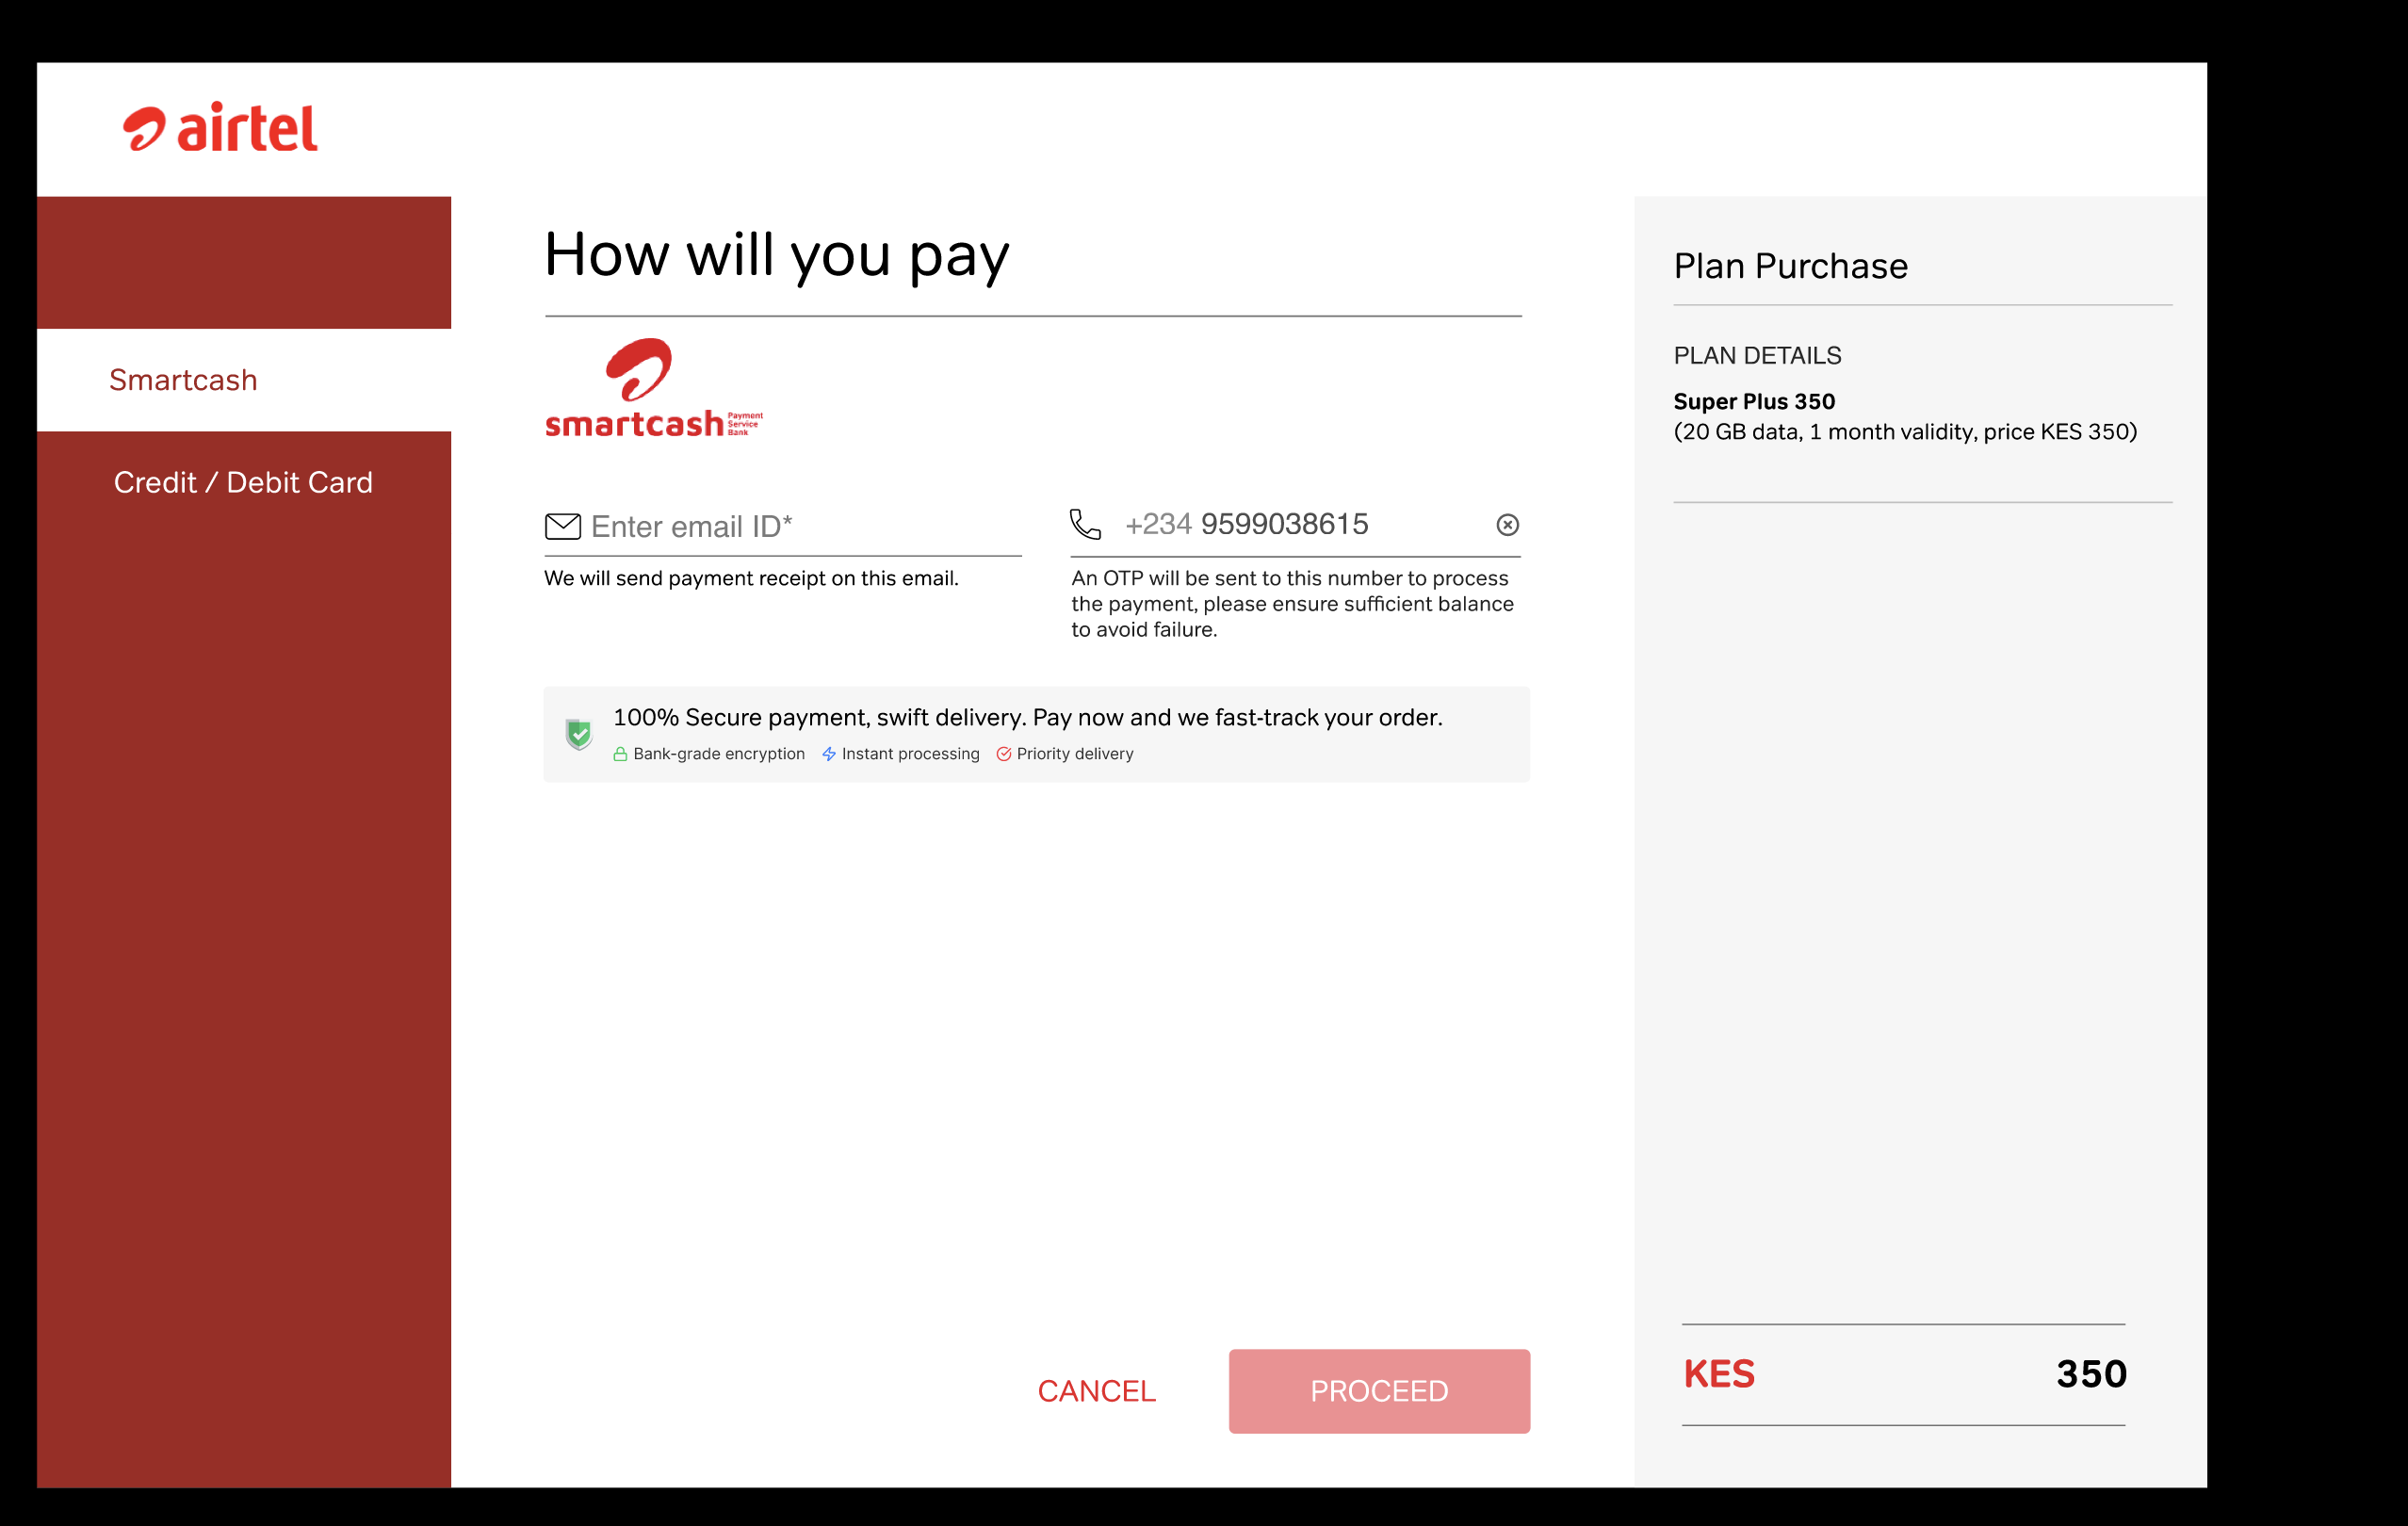
Payment page — Smartcash selected, plan purchase summary on right

Description
User is redirected to the Airtel payment gateway. The page title is "How will you pay". Payment methods are listed as tabs on the left: Smartcash, Credit / Debit Card.
For Smartcash, the user provides their email (for receipt) and phone number (pre-filled, used for OTP). A Plan Purchase summary on the right shows the plan name, description, and total amount.
The user clicks "PROCEED" to initiate payment or "CANCEL" to go back.

Fields
Payment Method Tabs: Smartcash, Credit / Debit Card
Email ID: For sending payment receipt. [Mandatory]
Phone Number: Pre-filled. OTP sent to this number. [Mandatory]
Plan Purchase Summary: Plan name, description, total amount (e.g., "KES 350")
PROCEED Button: Initiates payment processing
CANCEL Button: Returns to previous screen

Validations
- Email must be a valid email format.
- Phone number must be pre-filled and non-editable (or editable with valid Airtel number validation).
- "Please ensure sufficient balance to avoid failure" warning must be displayed.
- All payment data must be transmitted over HTTPS/TLS.
- PROCEED button should be disabled until all mandatory fields are filled.
________________________________________________________________________________

Step 6 — Payment: PIN Entry, Success & Failure
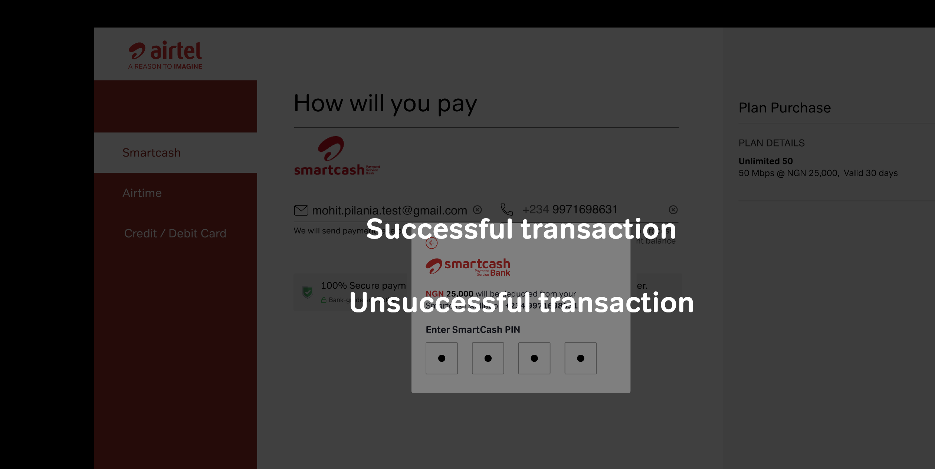
SmartCash PIN entry modal — leads to successful or unsuccessful transaction

Description
After clicking PROCEED with Smartcash, a PIN entry modal appears titled "Enter SmartCash PIN". The user enters their 4-digit PIN in masked input fields.
Two outcomes:
- Successful transaction — redirects to the Payment Success page (Step 7).
- Unsuccessful transaction — displays an error. The user can retry or return to the Data Pool section.

Fields
SmartCash PIN: 4-digit masked input fields. [Mandatory]

Validations
- PIN input must be masked (dots/asterisks) for security.
- PIN must be exactly 4 digits.
- On failure, a clear error message must be shown with retry option.
- Maximum retry attempts should be enforced (backend-driven).
- Session timeout should apply if PIN entry is left idle.
________________________________________________________________________________

Step 7 — Payment Success Confirmation
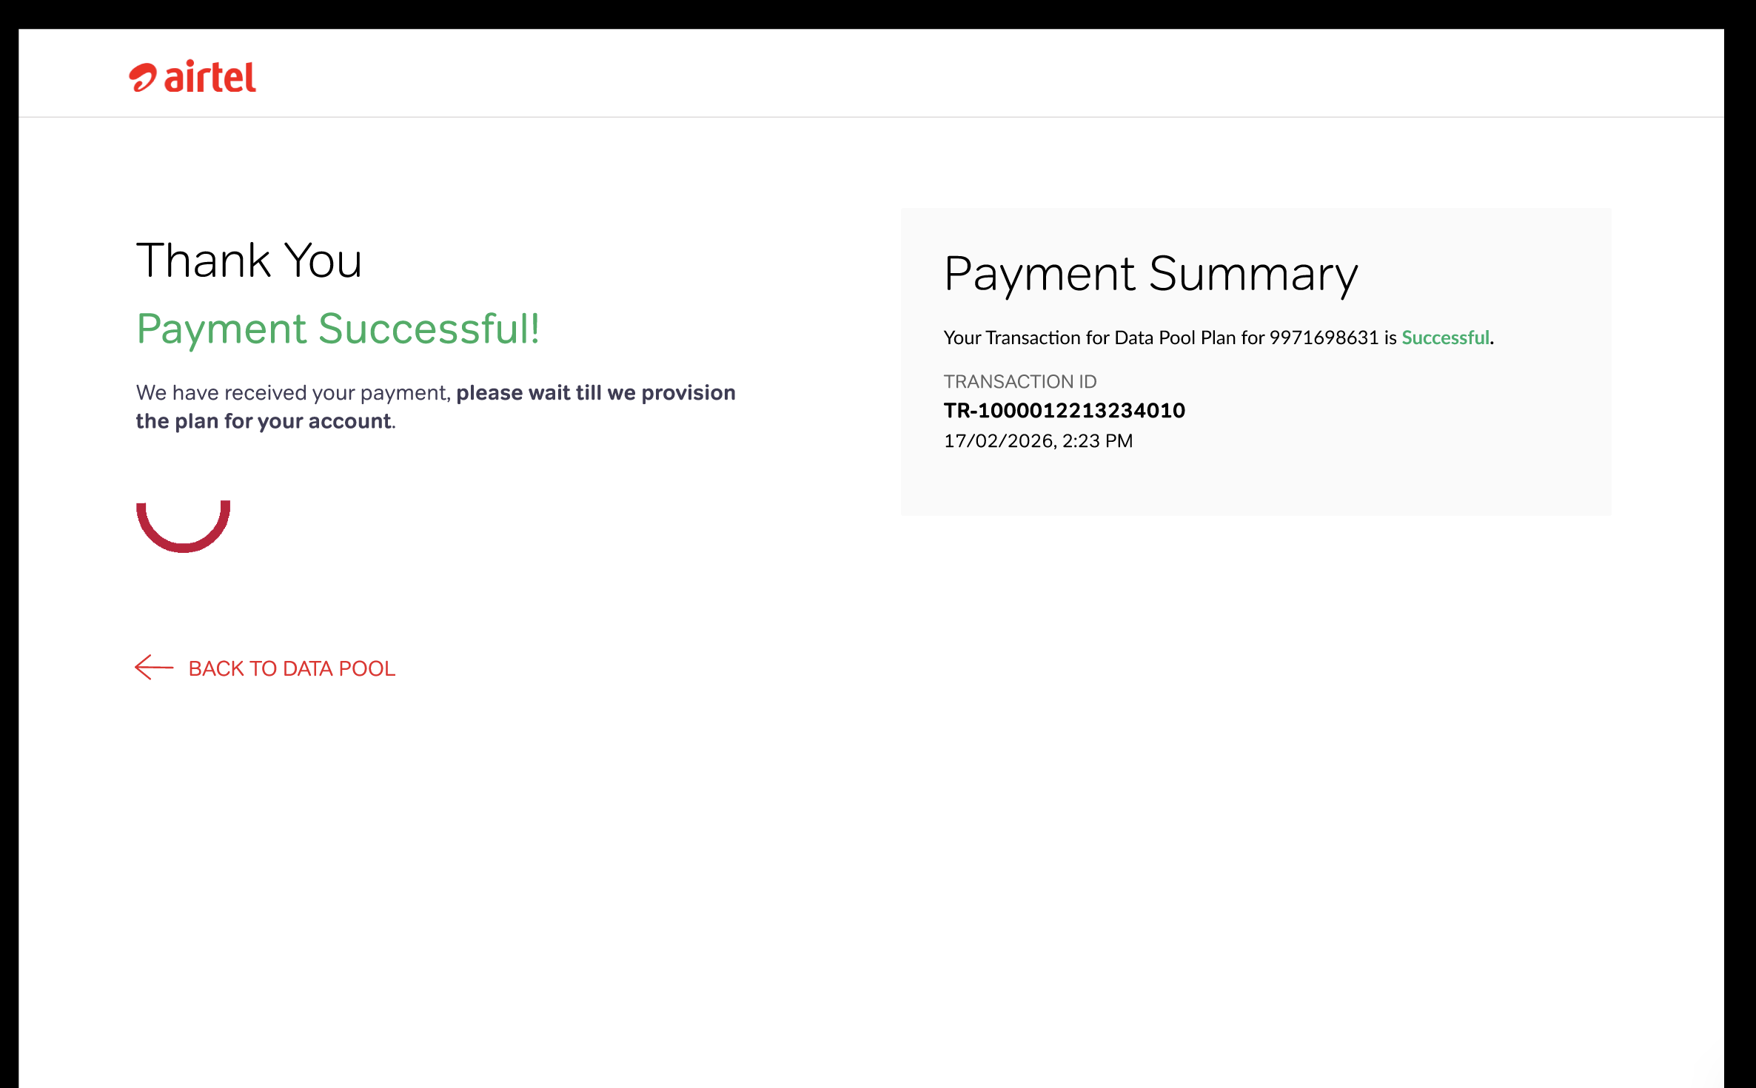
Payment Successful page with transaction summary and provisioning indicator

Description
On successful payment, the user sees a confirmation page with:
- "Thank You / Payment Successful!" message.
- "We have received your payment, please wait till we provision the plan for your account." with a loading spinner.
- A Payment Summary panel showing the transaction confirmation for the MSISDN, Transaction ID, and date/time.
- A "BACK TO DATA POOL" link to return to the Data Pool section.
After successful payment and provisioning, the user can proceed to add dependents.

Fields
Transaction Status: "Successful" (displayed in green)
Transaction ID: Unique reference. Example: "TR-100001221323401O"
Date & Time: Timestamp. Example: "17/02/2026, 2:23 PM"
MSISDN: Master number. Example: "9971698631"
BACK TO DATA POOL: Navigation back to Data Pool section

Validations
- Transaction ID must be generated and displayed immediately upon payment confirmation.
- Provisioning spinner should remain until backend confirms plan activation (or timeout with message).
- Transaction must be logged in the Transaction History tab.
________________________________________________________________________________

Step 8 — Security Deposit Service Request (Alternate Path)
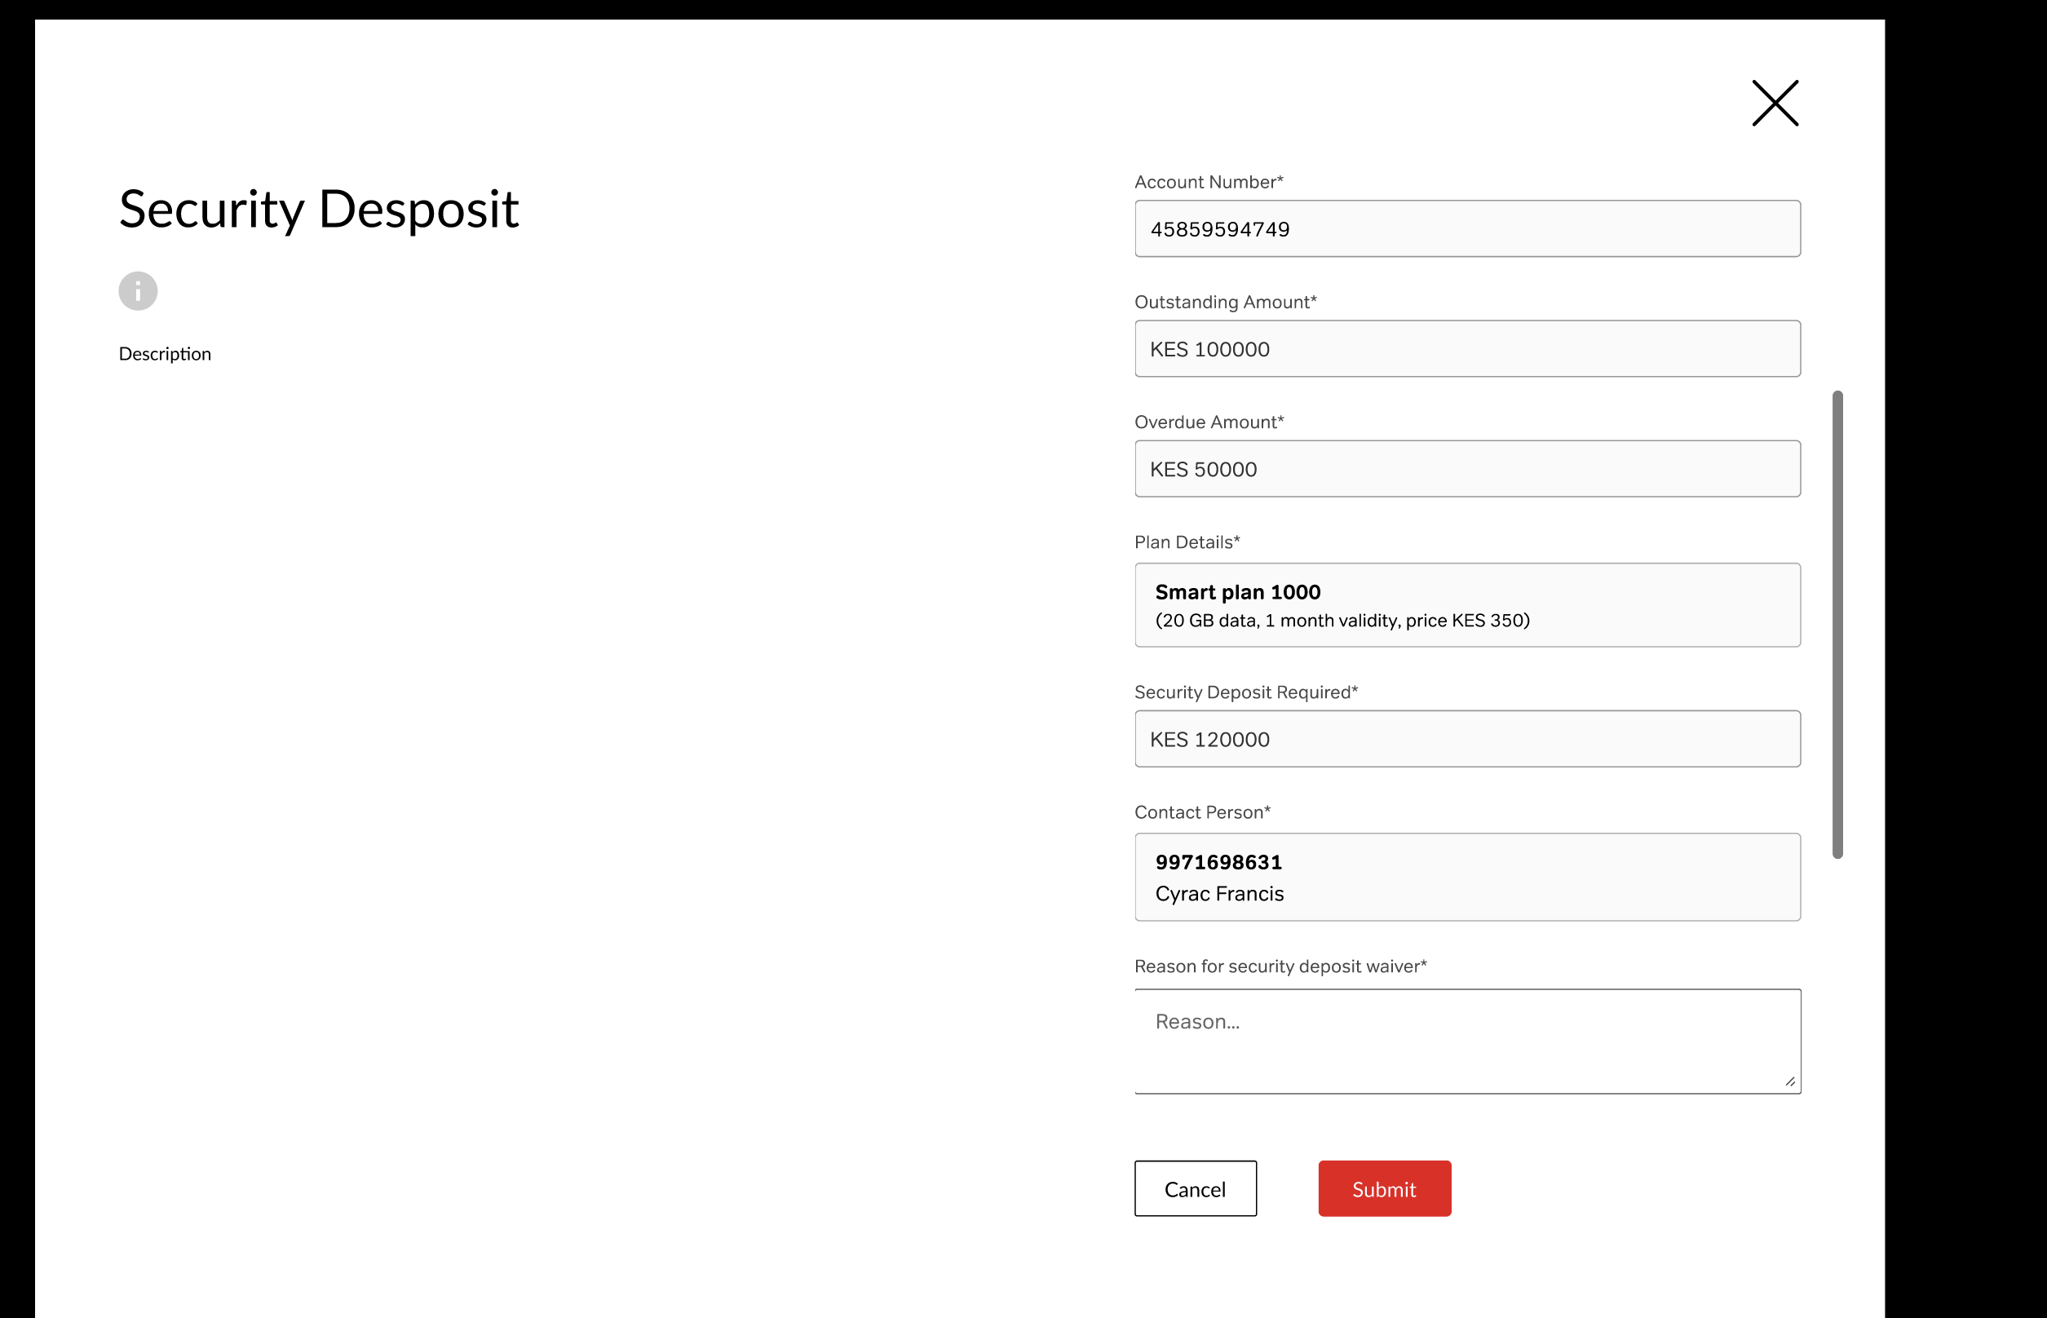
Security Deposit SR form — pre-filled account and plan details with waiver reason input

Description
If the user does not want to pay the security deposit upfront, they click the "Contact our customer support team" link from the Plan Confirmation modal (Step 4). This opens a Security Deposit service request form.
Most fields are pre-filled and read-only. The user only needs to provide the "Reason for security deposit waiver" and click Submit. A Service Request is created with status "Pending" and can be tracked on the SR detail page (Step 11).

Fields
Account Number: Pre-filled, read-only. Example: "4585959474 9" [Mandatory]
Outstanding Amount: Pre-filled, read-only. Example: "KES 100000" [Mandatory]
Overdue Amount: Pre-filled, read-only. Example: "KES 50000" [Mandatory]
Plan Details: Pre-filled, read-only. Example: "Smart plan 1000 (20 GB data, 1 month validity, price KES 350)" [Mandatory]
Security Deposit Required: Pre-filled, read-only. Example: "KES 120000" [Mandatory]
Contact Person: Pre-filled, read-only. Example: "9971698631 / Cyrac Francis" [Mandatory]
Reason for security deposit waiver: Textarea. User must enter justification. [Mandatory]

Validations
- "Reason for security deposit waiver" is mandatory. Submit button disabled if empty.
- All pre-filled fields must be read-only and not editable.
- On Submit, SR is created with SR Type = "Security deposit" and status = "Pending".
- User should receive confirmation with SR number after submission.
- Cancel button closes the form without creating an SR.
________________________________________________________________________________

Step 9 — Add / Remove Dependents (Individual & Bulk)

Description
Once a Data Pool plan is active, the user can manage dependent numbers from the Data Pool section. Two actions are available: Add Dependent and Remove Dependent. Each supports individual and bulk operations.

9a. Add Dependent — Individual
User clicks "Add Dependent" and enters a single mobile number to add to the data pool.

9b. Add Dependent — Bulk Upload
Visible as "Add Dependents Number/Upload Bulk" in the Buy Plan flow. User uploads a file (CSV/Excel) containing multiple dependent numbers.

9c. Remove Dependent — Individual
User clicks "Remove Dependent" and selects a number currently in the pool to remove. A confirmation dialog appears before execution.

9d. Remove Dependent — Bulk
User uploads a file (CSV/Excel) of numbers to remove in bulk.

Fields
Dependent Mobile Number (Individual): Input field for single number entry. [Mandatory]
Bulk Upload File: File input accepting CSV or Excel format. [Mandatory]
Confirmation Dialog (Remove): Confirm/Cancel prompt before removing a dependent

Validations
- Dependent number must be a valid Airtel number.
- Dependent must not already belong to another active data pool (for add).
- Maximum dependent limit per pool (e.g., 50). Block with message if reached.
- Bulk upload must validate all numbers and report success/failure count.
- Bulk file must be CSV or Excel format. Reject other formats with error.
- Removal requires a confirmation prompt before execution.
- All add/remove operations must be logged in the Self Service History tab.
________________________________________________________________________________

Step 10 — Data Pool Deactivation
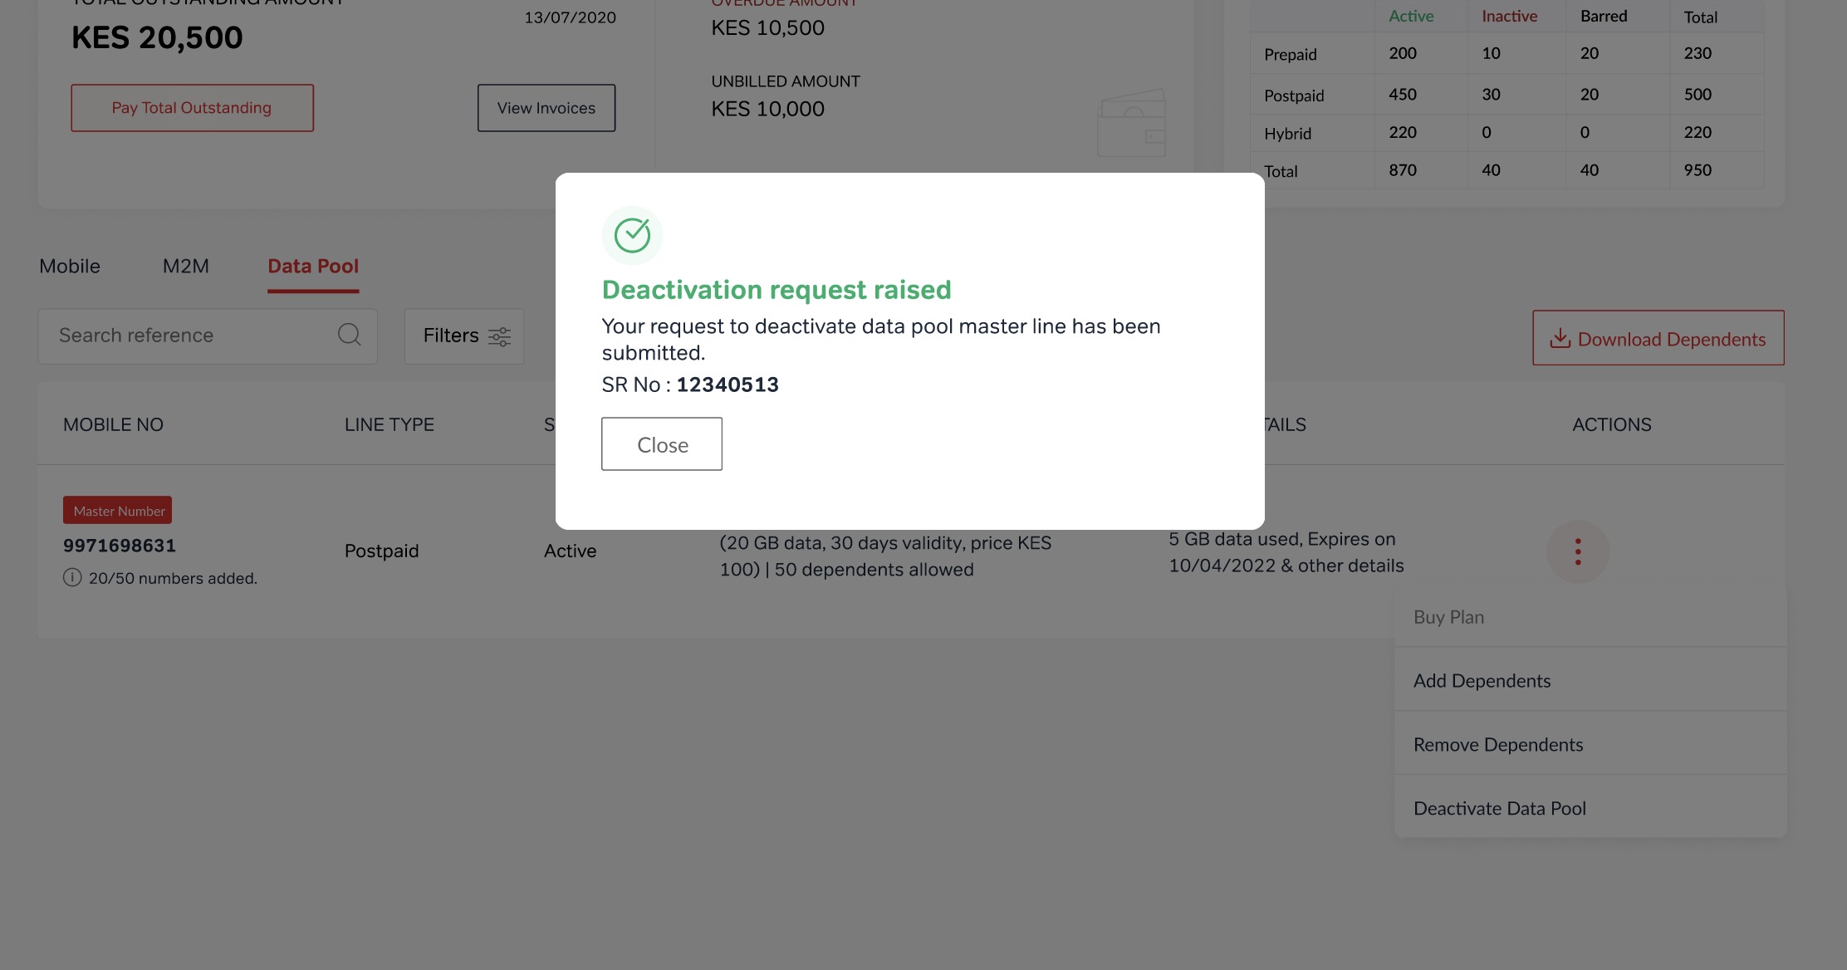
Deactivation request raised — confirmation with SR number, from the Actions menu

Description
On the Data Pool listing page, each active pool entry shows the master number, line type (Postpaid), status (Active), plan details, data usage, expiry information, and dependent count (e.g., '10/50 numbers added').
An Actions menu (three-dot icon) is available per entry with options: Buy Plan, Add Dependents, Remove Dependents, and Deactivate Data Pool.
Clicking "Deactivate Data Pool" immediately raises a Service Request. A confirmation dialog appears showing:
- "Deactivation request raised" with a green checkmark.
- "Your request to deactivate data pool master line has been submitted."
- The assigned SR Number (e.g., "SR No: 12340513").
- A "Close" button to dismiss the dialog.
A "Download Dependents" button is also available to export the current list of dependent numbers.

Fields
Master Number: Highlighted. Example: "9971698631"
Line Type: Example: "Postpaid"
Status: "Active"
Plan Details: Plan name, data, price, dependent limit
Data Usage: Consumed vs total. Example: "5 GB data used"
Expiry: Plan expiry date
Dependent Count: Added vs limit. Example: "10/50 numbers added"
Actions Menu: Buy Plan, Add Dependents, Remove Dependents, Deactivate Data Pool
SR Number (confirmation): Auto-generated. Example: "12340513"

Validations
- Deactivation is not immediate — it always creates a Service Request for back-office processing.
- SR number must be generated and shown in the confirmation dialog.
- Deactivation SR must appear in the Open SRs tab and be trackable on the SR detail page.
- Only active data pools should show the "Deactivate Data Pool" option.
________________________________________________________________________________

Step 11 — Service Request Detail Page
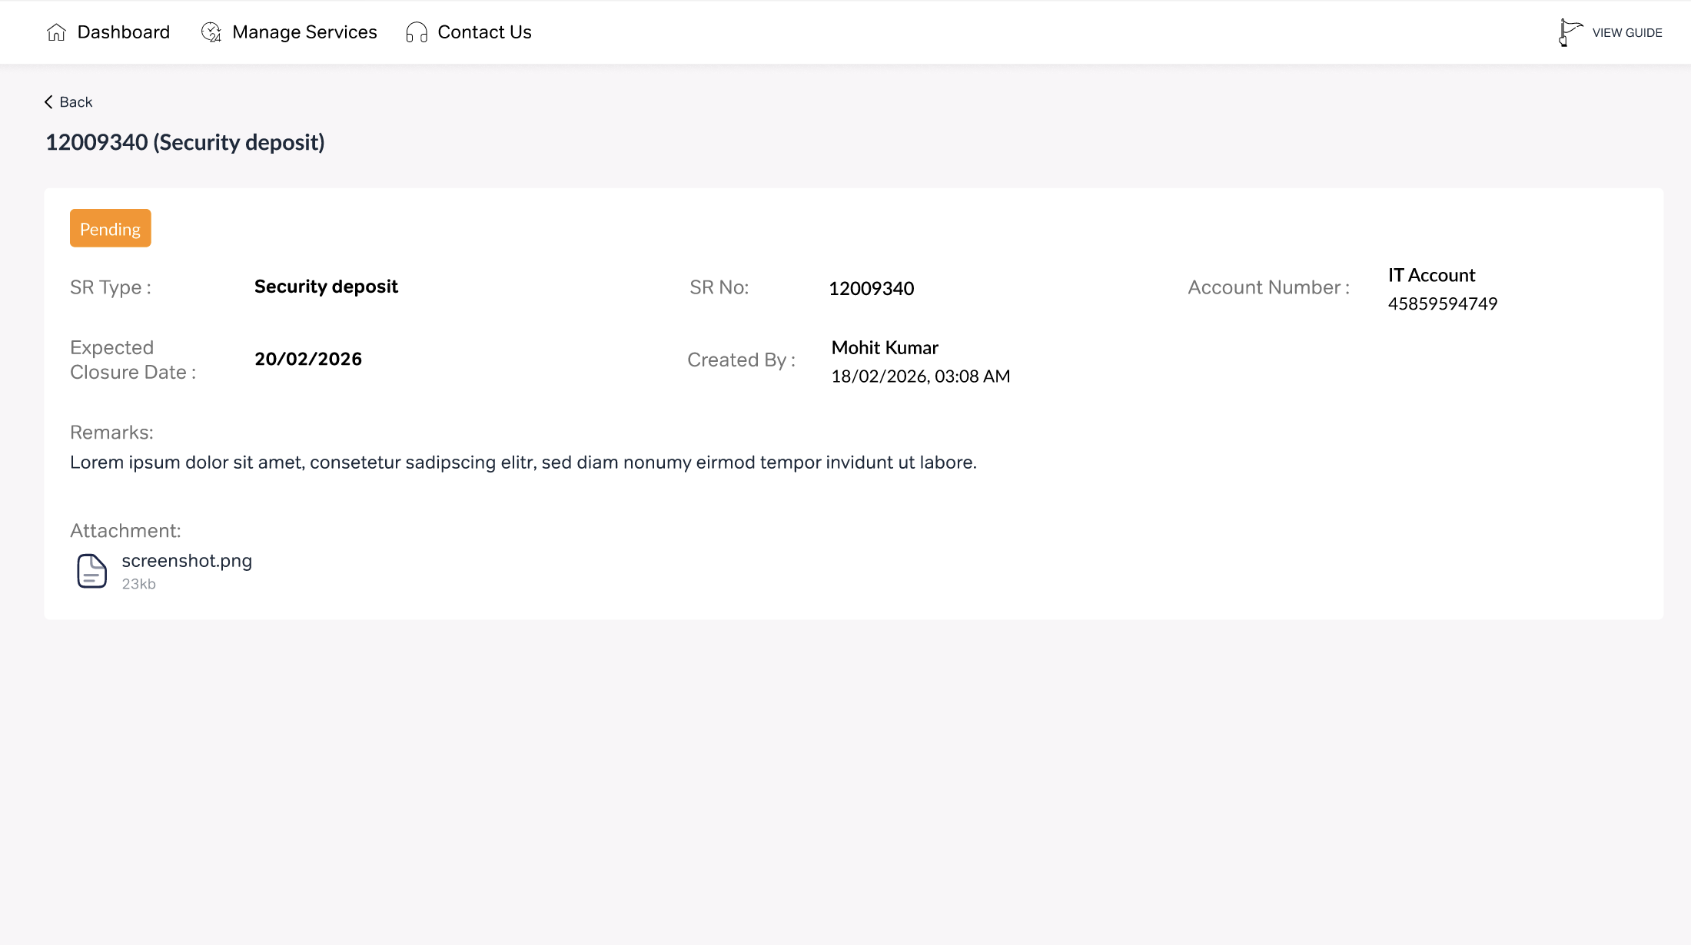
Service Request detail page — Security Deposit SR with status, creator, remarks, and attachments

Description
The user can view details of any Service Request (Security Deposit, Deactivation, etc.) by clicking the SR from the Open SRs or Closed SRs tab. The SR detail page shows all relevant information.
Breadcrumb navigation: Dashboard > Manage Services > Contact Us.

Fields
SR Type: Type of request. Example: "Security deposit"
SR No: Unique identifier. Example: "12009340"
Account Number: Enterprise IT account. Example: "4585959474 9"
Status: Current status with badge. Example: "Pending" (orange)
Expected Closure Date: Target resolution date. Example: "20/02/2026"
Created By: User + timestamp. Example: "Mohit Kumar, 18/02/2026, 03:08 AM"
Remarks: Free-text notes about the SR
Attachment: Attached files with name and size. Example: "screenshot.png, 5 Kb". Downloadable.

Validations
- All fields are read-only on the SR detail page.
- Status badge color should reflect state (orange=Pending, green=Resolved, red=Rejected).
- Attachments must be downloadable.
- Breadcrumb navigation must be functional.
- SR detail page must be accessible from both Open SRs and Closed SRs tabs.

— End of Document —
Data Pool Management — Requirement Document — Version 1.0 — 13 April 2026

